What is a Transvaginal Ultrasound?

Transvaginal Ultrasound is an examination of the female pelvis and urogenital tract (kidneys and bladder). It helps to see if there is any abnormality in your uterus (or womb), cervix (the neck of the womb), endometrium (lining of the womb), fallopian tubes, ovaries, bladder and the pelvic cavity. It differs from an abdominal ultrasound as it looks at the pelvic organs from inside the vagina.

The test is requested by your doctor if you have symptoms of pelvic pain, abnormal bleeding, to check for fibroids (muscle tumours of the uterus), polyps (areas of thickening of the lining of the uterus), ovarian cysts or tumours, infertility, or assessment of early pregnancy.

How do I prepare for
a Transvaginal Ultrasound?

No preparation is necessary. You will be asked to go to the toilet and empty your bladder prior to the test being performed. However it is useful to bring all of relevant previous examination images and reports for comparison report.

If you are wearing a tampon, it will need to be removed. If you are having a period this is not a problem and in some instances it is an advantage when assessing a variety of gynaecological problems.

You may be asked to sign a consent form prior to having the test.

It is a good idea to wear comfortable clothing that gives easy access to the lower part of your body.

What happens during
a Transvaginal Ultrasound?

After emptying your bladder you will be asked to undress from the waist down and you may be asked to wear a gown. You will then be asked to lie on an examination couch. Generally a sheet is provided to cover you. You will be asked to bend your legs and the transducer is inserted into the vagina.

The transducer is slightly larger than a tampon and especially shaped to fit comfortably into the vagina. A protective cover is placed over the transducer and lubricating gel is applied to it for ease of insertion. It is gently moved around and pictures or images of the pelvis are obtained.

If you do not wish to have a vaginal ultrasound you can request a trans-abdominal ultrasound be performed instead. You should inform the reception staff of this as you will need to drink 2-3 glasses of water 30 minutes prior to your test and have a full bladder. A trans-abdominal ultrasound uses a smooth, hand-held transducer. The abdomen is exposed and water based clear gel is applied to the skin and the transducer is moved gently across the abdomen with a sliding and rotating action.

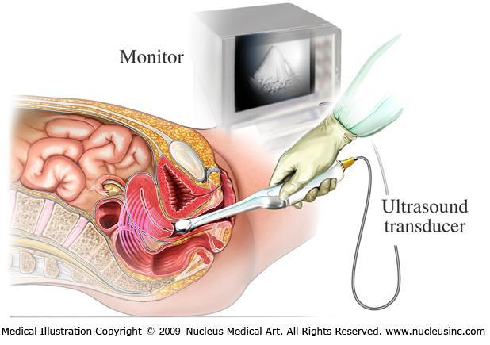
The sonographer uses a small, hand-held device called a transducer (or probe), which transmits ultrasound waves which are relayed back to the ultrasound machine to produce images or pictures on to an ultrasound screen. The examination is performed in ‘real time’, and the images you see on the screen show the inside of your pelvic area. Still pictures are taken during the examination.

Medical Illustration
Copyright ©2009
Nucleus Medical Art.
All rights reserved.
www.nucleusinc.com

Are there any after effects of
a Transvaginal Ultrasound?

There are no after effects of a Transvaginal Ultrasound. You will be able to resume normal activities.

How long does
a Transvaginal Ultrasound take?

The examination takes between 15-30 minutes.

Sometimes you will be asked to wait and have the images checked by the radiologist. Usually the referring doctor will be immediately contacted upon any concerning findings that need an urgent report and medical attention. You will be referred back to the referring doctor or the hospital to arrange the necessary treatment.

What are the risks of
a Transvaginal Ultrasound?

There are no known risks of performing Transvaginal Ultrasound. It is a technique which uses sound waves to obtain pictures or images and there is no radiation involved.

If you are pregnant, there are no risks to the unborn baby. If you are pregnant and your waters have broken but you are not in labour (premature rupture of the membranes), it is not advisable to have ultrasound due to a small increase in the risk of infection to your unborn baby.

If you are pregnant and known to have an abnormally low – lying placenta and you are experiencing vaginal bleeding, it is not advised to have Transvaginal Ultrasound as it could make the bleeding worse.

What are the benefits of
a Transvaginal Ultrasound?

The insertion of the transducer into the vagina allows a very close and clear view of the pelvic organs and very clear ultrasound images to be taken of the area. This will help to guide the discussion between you and your doctor about any further investigation or treatment that may be needed.

Who does the Transvaginal Ultrasound?

The examination is performed by sonographers, a health professionals specially trained and accredited to perform the test. Sonographers may be male or female. If you are not comfortable with a male you should let the reception staff know when making an appointment. In cases where the patient is young, a female chaperone may be requested. A partner, a female parent, female relative, or patient chaperone can be in the room at the consent of the patient.

How do I get my results?

The written report and images will be electronically or physically delivered to your referring doctor as soon as is practicable.

Alternatively you can pick it up or take films only and arrange to fax the report when it is available. Please let us know of your or your doctor’s preference. It is very important that you discuss the results with your referring doctor so that they can explain what the results mean for you.

This information is credited to Inside Radiology, Royal Australian and New Zealand College of Radiology (RANZCR).
insideradiology.com.au Feb 2015

